Acton Playing Fields & Village Hall
Lone Worker/Lone Adult on the Premises Risk Assessment
Assessment Date: 1/6/26
Assessor: Katie McSweeney
Next review date: 1/6/27

1. Purpose
To identify and control risks associated with employees, volunteers, trustees, hirers or contractors working alone or as lone adults on the premises at Acton Playing Fields and Village Hall. This assessment supports safe working practices, compliance with Health & Safety at Work Act 1974, and insurer expectations.

2. Scope
This assessment applies to:
- Charity manager and cleaner
- Trustees and volunteers undertaking tasks and performing ad-hoc duties
- Contractors working on site without direct supervision
- Hirers setting up or breaking down sessions

It covers both the Village Hall building and the Playing Fields, including the car parks, storage areas, plant rooms, and external grounds.

3. Lone Working Activities Identified
- Unlocking/locking the hall, setting up and breaking down sessions
- Cleaning, waste removal, and routine caretaking
- Maintenance tasks (lighting, heating, minor repairs)
- Groundskeeping and inspections
- Meeting contractors/hirers on site
- Responding to alarms or faults

Lone Worker/Lone Adult Risk Assessment Table
Hazard | Description | Potential Harm | C | L | RL | Control Measures
Slips, trips, falls, injuries | Uneven ground, wet floors, poor lighting, external pathways | Injury, inability to summon help | 3 | 2 | 6 | Maintain clear walkways; ensure external lighting is functional; lone workers carry mobile phone; regular inspections; avoid working at height when alone; do not use power tools alone
Medical emergency | Sudden illness, collapse, allergic reaction | Serious injury or fatality | 5 | 1 | 5 | Lone worker must have mobile phone; check-in system with designated contact; first aid kit accessible; avoid high-risk tasks alone; only take on tasks that can be managed with current level of fitness
Violence or aggression from public | Unauthorised persons on playing fields or hall grounds | Physical harm, intimidation | 3 | 2 | 6 | Keep doors locked when working inside; signage indicating staff-only areas; lone workers avoid confrontation and call police if needed; CCTV operational
Manual handling | Moving tables, chairs, sports/club equipment, waste bins | Back strain, physical injury | 3 | 3 | 9 | Training in safe lifting; use chair trolleys (max 10 chairs); avoid lifting heavy items alone; break tasks into smaller loads
Working at height | Using ladders for decorations, cleaning, maintenance | Falls causing serious injury | 4 | 3 | 12 | Prohibit ladder use when alone – kick stools in kitchen and main hall; require second person for stability and emergency support
Electrical or plant room hazards | Boiler room, fuse boards, lighting controls | Electric shock, burns, | 5 | 2 | 10 | Access restricted to trained personnel; no live electrical work when alone
Fire | Faulty equipment, cooking appliances, electrical faults | Burns, smoke inhalation | 5 | 1 | 5 | Lone workers know fire exits; no use of high-risk equipment alone; ensure fire alarm panel set; maintain clear escape routes
Security / unauthorised access | Lone worker confronted by intruder or finds building insecure | Harm, theft, distress | 4 | 1 | 4 | Lone worker to conduct visual check before entering; ensure doors locked behind them; CCTV and external lighting maintained
Outdoor hazards (Playing Fields) | Uneven terrain, weather, isolated areas | Trips, exposure, inability to call for help | 3 | 2 | 6 | Carry phone; avoid carrying out tasks in poor weather; ensure someone knows expected finish time; maintain pathways
Chemical exposure | Cleaning products, maintenance chemicals | Burns, respiratory irritation | 4 | 1 | 4 | Store chemicals securely; use PPE; only domestic products used
Animal encounters | Dogs off lead, wildlife in grounds | Bites, scratches, distress | 3 | 2 | 6 | Lone workers avoid approaching animals; report incidents
Vehicle movement | Car park traffic, contractor vehicles | Collision risk | 4 | 1 | 4 | High-visibility clothing; awareness of vehicle movements; avoid directing traffic alone; shared space and 5mph max signs installed
Alarm activation | Burglar or fire alarm triggers during lone working | Stress, unsafe investigation | 2 | 1 | 2 | Lone workers must not investigate alone; contact Charity Manager or Chairperson; ensure mobile phone signal available

C = consequence
L = likelihood
RL = risk level

Risk Matrix
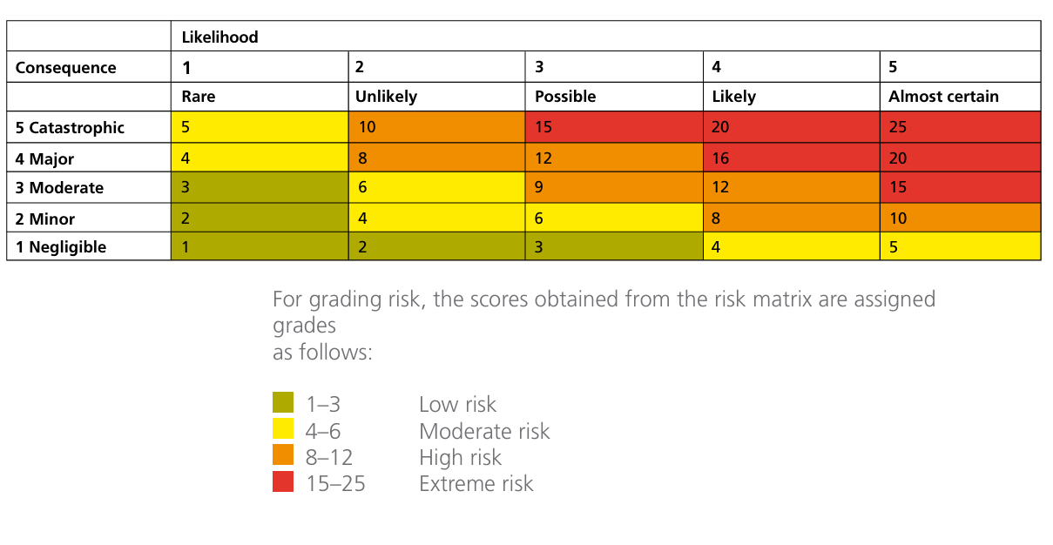
5. Lone Worker Controls (General)
Communication & Monitoring
- Lone adults/workers are encouraged to use the checklist to help inform their decision to work alone
- Lone adults/workers must carry a charged mobile phone at all times.
- A check-in/check-out system must be used (text or call to a designated contact).
- Expected start/finish times must be communicated.
Training
- Manual handling
- Awareness of emergency procedures
- Safe use of cleaning products and equipment
- Personal safety and conflict avoidance
Access & Security
- Lone workers must not allow public access.
- All external doors should remain locked during lone working.
- CCTV and external lighting should be maintained and checked regularly.
Emergency Procedures
- Lone workers must know the location of first aid kits and exits.
- No high-risk tasks (ladder work, electrical work, roof access) may be undertaken alone.
- Emergency contact numbers must be displayed clearly.
6. Residual Risk
With controls in place, residual risk is low to moderate, appropriate for a community building and open playing fields. Regular review ensures ongoing suitability.
7. Review Schedule
- Annual review by trustees
- After any incident involving lone working
- After significant changes to building layout, equipment, or staffing

