ACTON PLAYING FIELDS AND VILLAGE HALL
Health and Safety Policy

Contents:

Part 1 - General Statement of Policy 2
Part 2 - Organisation of Health and Safety 3
Part 3 - Arrangements and Procedures 4
1. Premises Licence 4
2. Fire Precautions and Checks 4
5. Procedure in case of accidents & First Aid 5
6. Lone Working 6
7. Smoking Drugs and Alcohol 6
8. Safety Rules 6
9. Contractors and DIY Volunteers 7
10. Insurance 8
11. Organisational Structure 8
12. Training and Knowledge. 8
13. Contact details for Organisations 8
14. Notices 8
15. Workplace Stress …………………………………………………………………………….. 8
16. Control of Substances Hazardous to Health (COSHH) 8
17. Review of Health and Safety Policy 9
Appendix A: Ecacuation Routes & Fire Equipment 10
Appendix B: Notices Posted at Vestibule 11
Appendix C: H&S Documents ………………………………………..………………………12

Part 1 - General Statement of Health & Safety Policy

This document is the Health and Safety Policy of Acton Playing Fields and Village Hall (APFVH).
Our policy is to:
a) Provide healthy and safe working conditions, equipment and systems of work for Management Committee members, hirers, users and other visitors.
b) Keep the village hall, its grounds and equipment in a safe and well-maintained condition for all users.
c) Provide such advice and information as is necessary for Management Committee members, hirers, users and other visitors.
It is the intention of Acton Playing Fields and Village Hall Management Committee to comply
with all relevant Health and Safety legislation and to act positively where it can reasonably do so to prevent injury, ill health or any danger arising from its activities and operations. APFVH activities are limited to services at the playing fields and village hall premises, it does not extend beyond this area and does not provide any transport services.

Acton Playing Fields and Village Hall Management Committee considers the promotion of the
health and safety of those who use its premises, including contractors who may work there, to be of great importance. The Management Committee recognises that the effective prevention of accidents depends as much on a committed attitude of mind to safety as on the operation and maintenance of equipment and safe systems of work.

To this end, the Committee will encourage its members, hirers, users and other visitors to engage in the establishment and observance of safe working and other practices. Committee members are encouraged to adopt a ‘watch out for others’ attitude towards safe practices.

The Management Committee will carry out risk assessments related to the business of hiring out the facility and record the assessment where necessary. Those (individuals or organisations) hiring all or part of the premises must assess the risks associated with their activities and equipment used and, where necessary, keep a record of the assessments.

Hirers, users and other visitors will be expected to recognise that there is a duty on them to comply with the practices set out by the Committee, with all safety requirements set out in the Standard Conditions of Hire, with safety notices on the premises and to accept responsibility to do everything they can to prevent injury to themselves or others.

To ensure the committee considers the importance of Health & Safety Reviews, ‘Health & Safety Review' will be a fixed item on the committee’s meeting agenda.

Name: Katie McSweeney
Position: Charity Manager
(On behalf of the Management Committee)

Date: March 2026

Part 2 - Organisation of Health and Safety
The Acton Playing Fields and Village Hall Management Committee has overall
responsibility for health and safety at Acton Playing Fields and Village Hall and takes
day to day responsibility for the implementation of this policy.

It is the duty of all hirers, users and other visitors to take care of themselves
and others who may be affected by their activities and to co-operate with the
Management Committee in keeping the premises safe and healthy.

It is the responsibility of hirers to ensure that adequate safeguards are in place
to protect the well-being of the disabled, children and vulnerable adults.

Should anyone using the hall come across a fault, damage or other situation
which might cause injury and cannot be rectified immediately they should
inform the Charity Manager or the Chairperson as soon as possible so that the problem can be dealt with.

Where equipment is damaged or otherwise faulty a notice should be placed
on it warning that it is not to be used and the Charity Manager or Chairperson informed as soon as possible.

The management Committee arranges for:

Weekly Inspections of Fire Equipment, Fire Warning System and Evacuation Routes
Weekly inspections of Cleanliness and Tidy order of the premises
Monthly Inspections (and replenishment) of the First Aid Boxes
Monthly testing of Emergency Lighting System throughout the premises
Hire Terms and Conditions and H&S information to Hirers
Regular reviews of risk assessments and policies
Six Monthly Water services inspection and cleaning
Annual review of Insurance cover - Premises, Employees and Public Liability

Documentation history and or logs are kept in support of the listed checks.

Part 3 - Arrangements and Procedures

1. Premises Licence
The hall is licensed for music, singing and dancing by Babergh District Council BPL0291

The hall is licensed for:
- Plays (indoors)
- Films (indoors)
- Indoor sporting events
- Live music (indoors)
- Recorded music (indoors)
- Performances of dance (indoors)
- Anything of a similar description to live or recorded music or dance (indoors)
- Supply of alcohol (On the premises)

2. Fire Precautions and Checks
The Management Committee has had an updated Fire Risk Assessment carried out in December 2025 in accordance with the Regulatory Reform (Fire Safety) Order 2005. This will be updated in December each year.

Plans of the hall showing the location of fire equipment, emergency routes and emergency exits are attached as Appendix A. Copies of the plans are displayed at the building’s two entrances. All building users, especially hirers and committee members should familiarise themselves with the building layout .

A ‘Fire Action’ notice is posted at the vestibule H&S noticeboard. There is no telephone at the premises. Hirers to ensure a suitable mobile is available.

Hirers and committee members must be familiar with location of emergency exits and evacuation routes, firefighting equipment and the fire alarm system. The fire alarm system does not automatically alert the fire brigade. It is the hirer’s responsibility to ensure that they have considered emergency evacuation and the complete evacuation from all areas of the building. The hirer becomes the 'Responsible Person'

When evacuating the building, all internal doors must be closed.

The Charity Manager, assisted by trustees, is responsible for testing equipment and keeping a testing log.

A Fire Risk Assessment is carried out and Fire Safety Policy isa reviewed minimum every 12 months

Local Fire Brigade Contacts
Sudbury Fire Station  Gregory Street  Sudbury  CO10 1AZ  T: 01284 741423 | Long Melford Fire Station  Hall Street  Long Melford  Sudbury  CO10 9HY

3. Building Electrical Safety (5-year EICR Test and Inspection)
Building Electrical Safety inspections will be carried out periodically and a copy of the certification held in the Charity Manager H&S file.
Portable Appliance Testing will be carried out annually and a copy of the test will be held in the Charity Manager H&S file.

4. Water Services Safety and Inspections
To keep the buildings water services safe from bacteria and legionella a Water Services Safety Policy is in place and regular inspections are carried out in accordance with the policy.

5. Procedure in case of accidents & First Aid
The location of the nearest Accident and Emergency Department is:
West Suffolk NHS Foundation Trust
West Suffolk Hospital
Hardwick Lane
Bury St Edmunds, Suffolk
IP33 2QZ
T: 01284 713000
(Approx. 25 minutes’ drive from the Hall)

There is also an Accident and Emergency Department at:
Colchester Hospital
Turner Road
Colchester, CO4 5JL.
01206 747 474
(Approx. 29 minutes’ drive from the Hall)
The location and telephone number for the nearest doctors’ surgeries are
Unity Health Care Group
Long Melford Practice, Cordell Road,
Long Melford, Sudbury CO10 9EP Tel: 01440 841300

Sudbury Health Centre
Church Field Road, Sudbury CO10 2YA Tel: 01787 881191

- APFVH does not provide either a trained first aider or an appointed person to be on the premises when the hall is used. Hirer’s risk assessment process should identify if first aid support is required.
- First Aid Boxes are located in the kitchen and the vestibule. The boxes are fitted with seals to readily indicate that they have been accessed.
- The person responsible for checking and replenishing the content is the Charity Manager
- There is no telephone at the premises. Hirers to ensure a suitable mobile is available.
- An Automated Emergency Defibrator (AED) is located outside the hall, to the right of the main doors.
- The accident forms are kept available in the blue folder next to the main hall noticeboard. A report must be completed whenever an accident occurs.
- Any accident or a near miss must be reported to the Charity Manager or Chairperson (see below for contact details)
- The person responsible for completing RIDDOR forms and reporting accidents
in accordance with the Reporting of Injuries, Diseases and Dangerous
Occurrences Regulations 1995 is the Charity Manager.

The recording of near misses, small cuts, trips and burns etc are important because it helps the Trustees to learn where small improvements or instructions can be changed. Reviewing near misses helps to prevent more serious accidents.

Contact details:
Chairperson: Tel: 07801 568126 Email: carolwhite412@btinternet.com
Charity Manager: Tel: 07531 786443 Email: actonvillagehall@aol.com

6. Lone Working
Lone working can create risks, APFVH has a Lone Working Policy in place for those working alone or attending the premises alone.

7. Smoking Drugs and Alcohol
The health, safety and wellbeing of all attendees are of paramount importance to the management committee.

The Management Committee encourages a drug free environment, which adheres to the Misuse of Drugs Act (1971) and the Psychoactive Substances Act (2016).

APFVH has a written policy covering Smoking, Drugs and Alcohol.

8. Safety Rules
The Standard Conditions of hire for the hall contain many health and
safety aspects. All hirers are expected to read the conditions and to check the box on the
online hiring form as evidence that they agree to the conditions.

The Standard Conditions state that all statutory or local regulations and rules
for public safety must be strictly observed by hirers and fire and safety
equipment must not be misused or removed from its designated location. Fire
and other exits must not be obstructed. Illuminated fire exit signs must be on
for all public entertainment.

A safety check is carried out monthly and any risks reported to the Management
Committee. The Committee maintains a Risk Register which is reviewed at its
management meetings.

Thers is no landline at the hall, in case of emergency it is the hirer’s responsibility to ensure a working mobile telephone is available throughout the hire period.
The driveway from the High Street and car parks are a ‘Shared Space’. Pedestrians and drivers must watch out for each other. Max vehicle speed is 10mph.

Vehicles must not be left unattended in the bay opposite the disabled parking bays. This bay is to be kept clear for emergency vehicles.

Signs indicating max speed and informing drivers and pedestrians that the driveway and car parks are a SHARED SPACE are displayed and maintained.

9. Contractors and DIY Volunteers
The Management Committee, Charity Manager or the Trustee engaging the contractor will check with contractors (including self-employed persons) before they start work that

• The contract is clear and understood by both the contractors and the Committee

• The contractors (or volunteer) are competent to carry out the work (eg have appropriate qualifications, references, experience)

• Contractors have adequate public liability insurance cover

• Contractors have seen the APFVH's health and safety file and are aware of any hazards which might arise (eg electricity cables or gas pipes)

• Contractors do not work alone on ladders at height (if necessary, a volunteer should be present)

• Contractors have their own health and safety policy for their staff

• The contractor knows which member of the committee is responsible for overseeing that their work is as required and to a satisfactory standard

• Any alterations or additions to the electrical installations or equipment must conform to the current regulations or the Institute of Electrical Engineers Code of Practice

• Where appropriate a Hot Work Permit will be issued to contractors.

- Thers is no landline at the hall, in case of emergency it is the contractor’s/DIY volunteer’s responsibility to ensure a working mobile telephone is available throughout the onsite period.
- The Charity Manager must be advised if there is a need to use flammable liquids.

10. Insurance
The Committee will annually assess the Employer’s Liability and Public Liability insurance cover to ensure that adequate cover is in place.

The Committee will annually assess the Property and Business Risk insurance cover to ensure that adequate cover is in place.

11. Organisational Structure
For details of the Charity organisation structure please refer to our Organisation Structure Document.

12. Training and Knowledge.
The Chairperson will review the Charity Manager’s Performance annually and identify any training that will support the job holder.
The Charity Manager should identify training sessions that will assist to improve knowledge and qualifications in carrying out their responsibilities and duties.

Trustees are encouraged to seek out training that will assist them in their duties as a trustee of the charity. At the Charity’s AGM all trustees are instructed to familiarise themselves with Trustees’ Responsibilities information at the Charity Commission’s website and the Charity’s Health and Safety Policy.

Nobody should be asked to tackle a task for which they have insufficient qualification and skills.

13. Contact details for Organisations which can give advice on health and safety.

Babergh District Council maintains a list of useful relevant contacts here:

https://www.babergh.gov.uk/w/health-and-safety-useful-information

14. Safety and Warning Notices
A list of Health, Safety and Warning notices is shown at appendix B

15. Workplace Stress
We are a responsible organisation / employer and are aware of our duty of care regarding the mental health and welfare of our staff and volunteers. For this reason, APFVH have adopted a Managing Workplace Stress Policy.

16. Control of Substance Hazardous to Health (COSHH)
The law requires a business, which uses substances that might cause harm to health, to control the risk to its employees and hall users. APFVH Management Committee have assessed the risk relating to products stored and used at the premises. The Committee have assessed the risks to health associated with below products authorised to be at the hall and drawn up a Risk Assessment & Safe Rules Policy which is reviewed annually by the committee

17. Review of Health and Safety Policy

The Management Committee will review this policy annually. The date of all reviews will be recorded below and signed by the Charity Manager or a Trustee below. It is important that all trustees are made aware of any changes/updates.
Annual or change | Date | Name | Position
Annual | 30/04/25 | G Round | Trustee
Updates | 08/05/26 | G Round | Trustee

Appendix A:
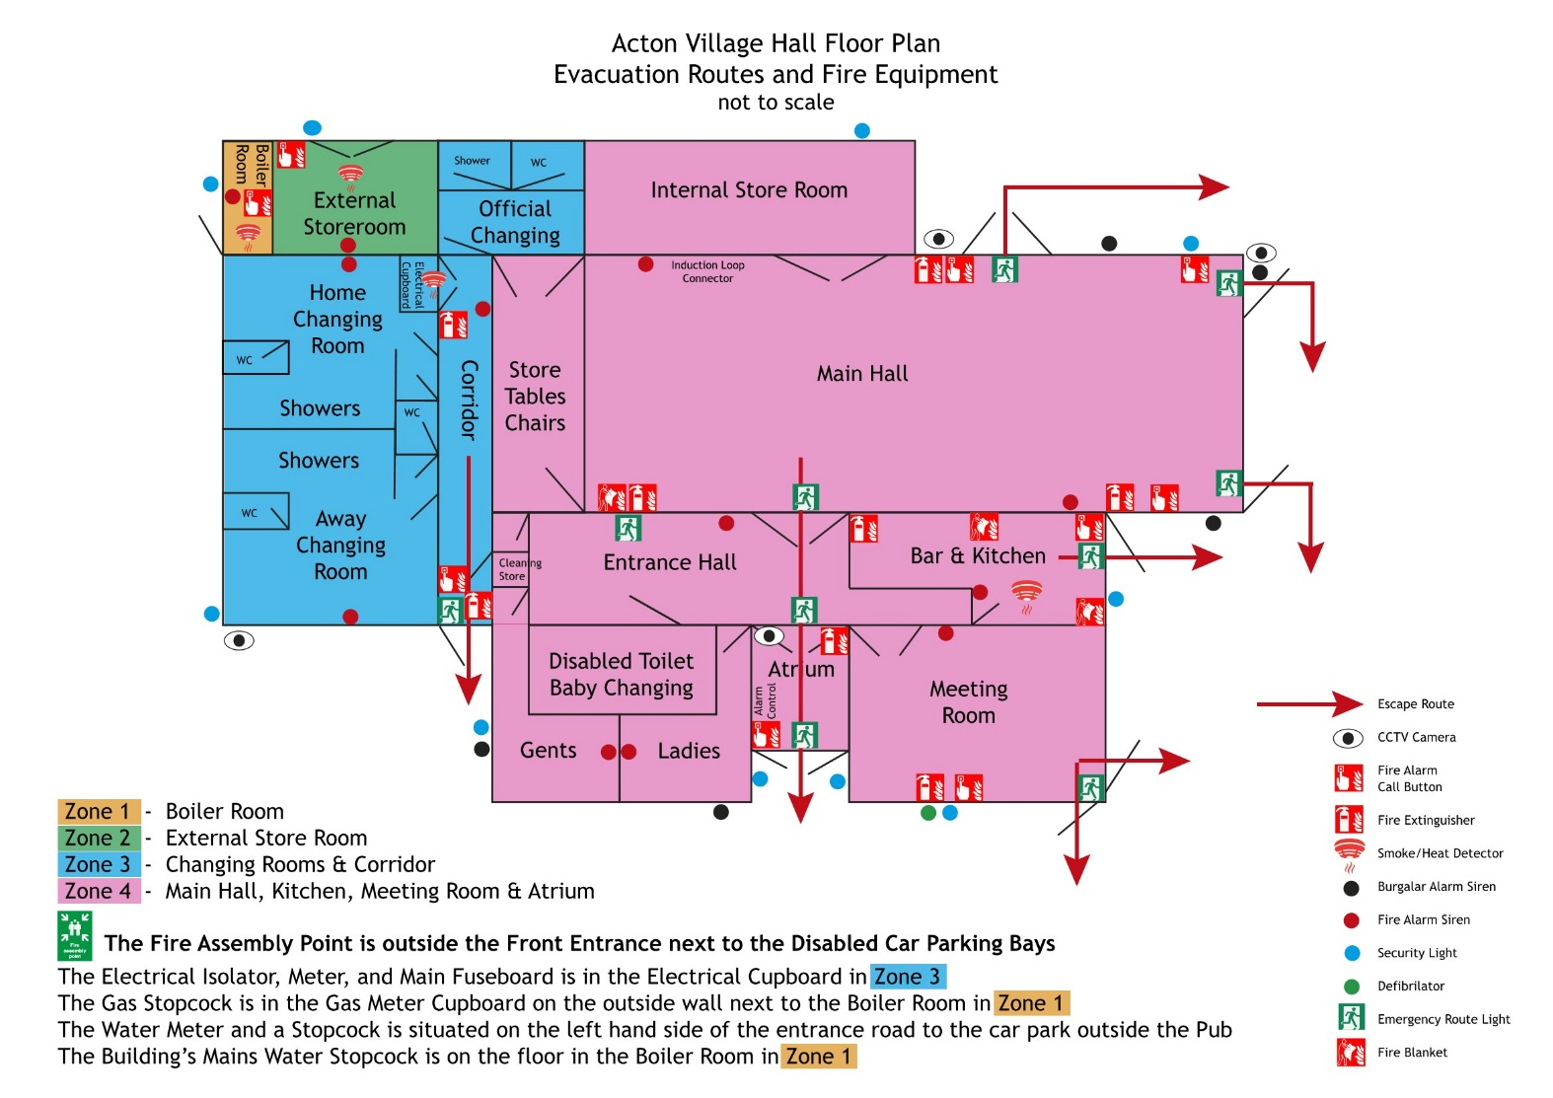
Evaluation Routes and Fire Equipment

Appendix: B
Notices posted at the main vestibule noticeboard.

- H&S General Statement of Policy - (Part 1 of our H&S Policy)
- H&S Law – What You Need to Know
- In Case of Fire Notice
- First Aid
- Manual Lifting Advice
- Electric Shock – First Aid

Other Notices.
- No Smoking or Vaping on Premises (posted at 2 x entrance doors)
- Chair Store - Safety Instruction - Stack 10 high and Trolley Use (posted on storeroom door and storeroom wall)
- Table Store - safety Instructions - (posted on storeroom door)
- Evacuation Routes & Fire Equipment (posted at main entrance and side entrance)

Appendix: C

Health & Safety Shared Documents.

Health & Safety Statement and Policy (this document)

Fire Risk Assessment and Fire Safety Instructions

Drugs, Smoking and Alcohol Policy

Control of Substances Hazardous to Health (COSHH) - Risk Assessment and Safety Rules

Lone Working Policy

Organisation Structure Statement

Managing Workplace Stress Policy

Bouncy Castles Policy - Special Conditions Apply

Terms and Conditions of Hire

Premises Health and Safety Audit - Risk assessment

